Saemi Ramirez

011926418

D211 Advanced Data Acquisition

9/8/2024

WGU

1. Copy of Dashboard
   1. Submitted final_combined.csv. Final_combined.csv file is the one from D210 class which is combined with WGU medical set and the demographic and questionnaire data sets from NHANES (National Health and Nutrition Examination Survey) 2017 – 2018. Original external datasets are also submitted (demographic.csv and questionnaire.csv).
   2. Step-by-step instructions on how to have the dashboard appear fully operational on a default version in Labs on Demand.

Accomplished dashboard will be looking like the following screenshot.

* + 1. SQL Database
       1. Open PostgreSQL, right click on “Database” then click “Database” under “Create”

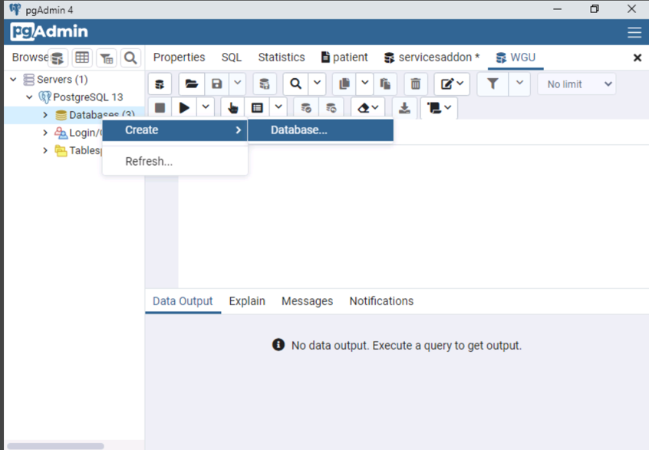

* + - 1. Name the database as “medical_d211”, then click save

* + - 1. Expand the database (medical_d211) just created

* + - 1. Click “Query Tool” for the query editor

* + - 1. Click the “Open File” icon and load “final_combined”, then click “Select”

* + - 1. Click “Execute” button to run the query to create a table

* + - 1. Under the “medical_d211” database, expand “Schemas” then “public”. Right-click on “Tables” and click “Refresh”

* + - 1. Once the “final_combined” table is generated under the “Table”, right-click on “final_combined” under table on the left-hand side, then click “Import/Export”

* + - 1. First, click “Export” to switch the Import/Export to “Import”.  
         Next, click the three-dot to open the file, then double-click “final_combined.csv”.

Lastly, click “No” for Header to switch to “Yes”.

Scroll down all the way, then click “OK”

* + 1. Tableau
       1. Open the locally installed Tableau, scroll down the menu on the left. Click “More” under “To a Server”. Click “PostgreSQL” on the right

* + - 1. Fill any missing values as following screenshot. The password is ‘Passw0rd!’

* + - 1. Drag “final_combined” table to the right panel if already not automatically done so. Then click “Sheet 1” on the bottom tab next to the “Data Source”

* + - 1. Right-click on “Age”, click “Bins” under “Create”

* + - 1. Type “Age (5-Yr) on New field name and put 5 for size of bins. Then click OK

* + - 1. Drag “Age (5-Yr)” and “Source” to the columns and “Age” to Rows. The age will automatically set as SUM(Age)

* + - 1. Click the arrow next to “SUM(Age)”. Select “Measure (sum)”, then click “Count”

* + - 1. Drag “Source” over to “Color” under Marks to make color changes between NHANES and WGU

* + - 1. Drag “Age” over to “Label” under Marks to show the numbers on the graph

* + - 1. Click the down arrow next to the “SUM(Age)” under Marks. Click “Measure(Sum)” then change to “Count”
      2. Double click “Sheet 1” on the bottom tab to rename it to “Age”
      3. Click “New Worksheet” icon next to “Age” on the bottom tab. Once it changes to “Sheet 2”, double click it to rename to “Marital”
      4. As you can see on the following screenshot, drag “Marital” and “Source” to Columns and “Marital” again to Rows. Drag “Source” over to “Color” under Marks to differentiate between WGU and NHNAES

* + - 1. Click the arrow next to “Marital” on Rows. Go to “Measure” then click “Count”

* + - 1. Drag “Marital” to “Label” under Marks like step 9. Click the down arrow next to the “Marital” under Marks. Click “Measure” then change to “Count”
      2. Click “New Worksheet” icon next to “Marital” on the bottom tab. Once it changes to “Sheet 3”, double click it to rename it to “Gender”
      3. First, change the chart option under Marks from “Automatic” to “Pie”.   
         Drag “Source” to Columns.  
         Drag “Gender” over to “Color”.  
         Drag “Gender” over to “Label” under Marks, then the “Gender” will be created under the Marks with “Label” icon on the left. Click down arrow of the “Gender”, go to “Measure”, select ”Count”.  
         Do the same thing for “Gender” with “Angle”.

* + - 1. Click “New Dashboard” icon on the bottom tab and rename it “D211 PA”
      2. Drag “Age”, “Marital”, and “Gender” sheets to the right and arrange how you want it to be

* + - 1. Save the work with “Save As” function under “File”
  1. Step-by-step instructions to help users navigate the dashboard
     1. Upon clicking to “D211 PA” on the bottom tab, the first two charts illustrate the comparison between these two sources in terms of age (5-year increment) and marital status. The pie chart on the bottom left represents the gender distribution. The purpose of the demographic dashboard is identifying the trends by revealing patterns in the distribution of patients across different age groups, marital statuses, and genders, which may be relevant or understanding the population’s health dynamics.
  2. Submitted “final_combined” file

1. Panopto Link: <https://wgu.hosted.panopto.com/Panopto/Pages/Viewer.aspx?id=14b61c2f-0de5-4ed1-b1a3-b1e500d9f44c>
2. Report
   1. By comparing the NHANES dataset with WGU medical dataset, the stakeholders can identify the demographics of the patients such as age, marital status, and gender between two distinct populations.
   2. Tableau 21.4 was used for this project. Tableau is ease of use with drag-and-drop interface which makes it accessible to users with limited technical knowledge. Tableau supports integration with various data sources such as (excel, SQL, etc.). It also allows to blend multiple datasets, making it easier to work with diverse source of information. Tableau provides interactive dashboards where users can drill down into data, filter, and explore trends and patterns dynamically.
   3. I used the one final data set that I used in D210 which is combination of questionnaire and demographics from NHANES and WGU medical dataset.   
      The NHANES dataset contained several variables that aligned with those in the WGU medical dataset. Three demographic variables for the ‘demographic.csv’ file were included: RIDAGEYR for age, RIAGENDR for gender, and DMDMARTL for marital status. The marital status categories were coded as follows: 1 for married, 2 for widowed, 3 for divorced, 4 for separated, 5 for never married, 6 for living with a partner, and a period (.) for never married because the ages for this category were under 18.

Not used columns were deleted during D210 project and NHANES datasets values were replaced to align with WGU medical datasets.

* 1. Summarize the steps used to create the dashboard
     1. Connect PostgreSQL to Tableau
     2. Age
        1. Create a numeric bin based to group the ages 5-years each
        2. Drag the 5-yr bin and Source to columns
        3. Drag Age to rows then change the Age to count from sum
        4. Drag the source over the Color
        5. Drag Age over the Label and change the measure from sum to count
     3. Marital
        1. Drag Marital and Source to columns
        2. Drag Marital to rows then change the Marital to count from sum
        3. Drag source over the Color
        4. Drag marital over the Label then change the measure from sum to count
     4. Gender
        1. Change the chart type to Pie
        2. Drag Source to columns
        3. Drag Gender over the Color
        4. Drag Gender over the Angle and change the Gender from sum to count
        5. Drag Gender over the Label and change the Gender from sum to count
     5. D211 PA (dashboard)
        1. Drag Age, Marital, and Gender sheets to the dashboard page on the right and arrange
  2. The dashboard show the distributions of age groups, the different marital groups (married, single, widowed, divorced, etc.), and the gender (male, female, non-binary). These supports the which illness or condition are more affected by highlighted groups along with the circumstances or environment, and the biological status.
  3. The biggest limitation is the small number of the information gathered from the patients for the analysis compared to the entire population of US. This analysis would not represent the distribution of gender, age, and marital status of U.S.

1. List the third-party code

N/A

1. List the third-party in-text citations

Curry, Caleb. *SQL Server 12 – Referential Integrity*. YouTube. (December 21, 2016). <https://www.youtube.com/watch?v=5hFPoBWCdQA>